# [[2, Background: Rel-19 RAN1 proposal (by other companies)]]

Referring to Figure 2, aspects of the present disclosure include the identification of inventors associated with the development of innovative SRS port grouping for enhanced MIMO performance in foldable devices. The inventors listed are Harish Nagisetty, Devendra Ponnapureddy, and Carrol Speir. In this aspect, the contributions of these individuals to the research and development efforts are recognized, highlighting their roles in advancing the technology.

# [[3, Background: 2-CW and single-CW receiving]]

The prior solutions include the implementation of a reduced complexity MIMO receiver that utilizes two Rx port groups for effective operation. In scenarios where the rank is greater than 4, a 2-CW PDSCH is transmitted, targeting each Rx port group respectively, as illustrated in Fig (a). For cases where the rank is less than or equal to 4, the user equipment (UE) may employ LLR combining from the demodulation of the two Rx port groups, as depicted in Fig (b). Alternatively, the UE may opt to utilize only one of the two Rx port groups, which could either be a fixed selection or the one exhibiting superior SNR. This approach aims to enhance overall system efficiency while addressing the complexities associated with MIMO technology.

# [[4, Background: SRS for antenna switching (xTyR)]]

Aspects of the present disclosure include the configuration of SRS (Sounding Reference Signal) resources for antenna switching in xTyR setups. In an SRS resource set, where the parameter "usage" is configured as "antennaSwitching," a total of \( Q = \frac{y}{x} \) SRS resources may be defined, each possessing \( x \) ports. These \( Q \) SRS resources are transmitted in distinct symbols using Time Division Multiplexing (TDM). Each of the \( Q \) SRS resources may be associated with different User Equipment (UE) antenna ports, ensuring that no two resources share the same port assignment. Historically, the configurations have adhered to the principle that \( y \) is an integer multiple of \( x \), with examples including 1T2R, 2T4R, and 1T4R. However, it is noted that future developments may introduce scenarios that deviate from this integer-multiple principle, such as configurations like 4T6R or 3T8R.

# [[5, Motivation and issue]]

Aspects of the present disclosure include the potential for MIMO receiver complexity reduction through the strategic implementation of SRS port grouping, particularly in the context of foldable smartphones. The configuration of two Rx antenna groups, which correspond to two SRS port groups, may be mounted on the distinct halves of the foldable device. This arrangement is necessitated by the physical limitations imposed by the RF circuitry, which may not traverse the hinge of the device. The design considerations for SRS port grouping are critical, especially for configurations such as 3T6R, 4T6R, and 3T8R. The challenges associated with accommodating these configurations while ensuring optimal performance and compliance with existing standards may require innovative approaches. The implications of these design choices may significantly influence the overall efficiency and effectiveness of MIMO technology in foldable devices.

# [[6, Proposal for 3T6R]]

Referring to Figure 6, aspects of the present disclosure include an examination of the DIF-FFT algorithm, which reveals that all stages, with the exception of the first, contain repeated and independent sub-problems. It is proposed that the first stage be implemented fully, while only one sub-problem from the second stage and the corresponding number of sub-problems from further stages need to be executed. This approach aims to enhance computational efficiency by reducing unnecessary repetitions in the algorithm, thereby streamlining the overall process.

# [[7, Proposal for 4T6R]]

Referring to Figure 7, the content delineates a method for decomposing a 256-point DFT into smaller DFTs, specifically into 16-point DFTs and 4-point DFTs. In this aspect, the process is illustrated through a series of visual elements that convey the systematic breakdown of the DFT, enhancing computational efficiency. The left section of the figure displays the initial decomposition of the 256-point DFT, which is then represented as multiple smaller DFTs on the right side. This approach may facilitate improved processing speeds and reduced complexity in MIMO systems, particularly for foldable devices. The directional flow indicated by the arrows signifies the transformation from a larger DFT to smaller components, emphasizing the systematic nature of the proposed solution. The structured arrangement of the smaller DFTs showcases how the overall computational load may be distributed, potentially leading to enhanced performance in practical applications. Each step in the decomposition is crucial for understanding the efficiency gains that may be achieved through this method.

# [[8, Proposal for 3T8R (Alt1)]]

Referring to Figure 8, the example presented illustrates a radix-4, 256 point FFT. In this aspect, the first stage is described as computing a 256-sample result in the initial cycle. This stage provides the first 64 samples to the pipeline formed by the second, third, and fourth stages. The subsequent samples are allocated to the pipeline in groups of 64 over the next three cycles. Once all four groups have been processed, the data can be reordered to achieve the final result. It is noted that a fully parallel design would allow for the acceptance of new input every cycle; however, this particular design can only accommodate new input every four cycles.

# [[9, Proposal for 3T8R (Alt2)]]

Referring to Figure 9, a detailed flow diagram is presented that outlines the proposed solution. In this aspect, the diagram illustrates a systematic approach divided into four stages, each involving a series of constant multiplications. - **Stage 1** emphasizes the initial step where inputs are grouped, and the necessary constant multiplications are performed. This stage serves as the foundation for the subsequent processing. - **Stage 2** continues the operation by further processing the outputs from Stage 1, where additional constant multiplications are executed to refine the results.- **Stage 3** follows, where the outputs from Stage 2 undergo further computations involving constant multiplications, enhancing the accuracy and reliability of the data.- **Stage 4** completes the process by compiling the results from Stage 3, again involving constant multiplications to finalize the output.This structured methodology highlights the systematic progression of data through each stage, ensuring that each operation builds upon the previous one, ultimately leading to enhanced computational efficiency in the proposed solution.

# Extracted Images

Image from Slide 2:

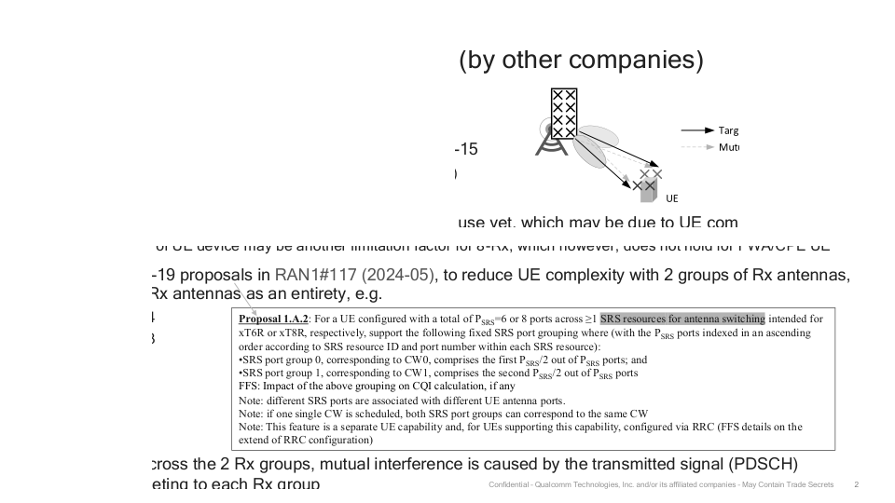

Image from Slide 3:

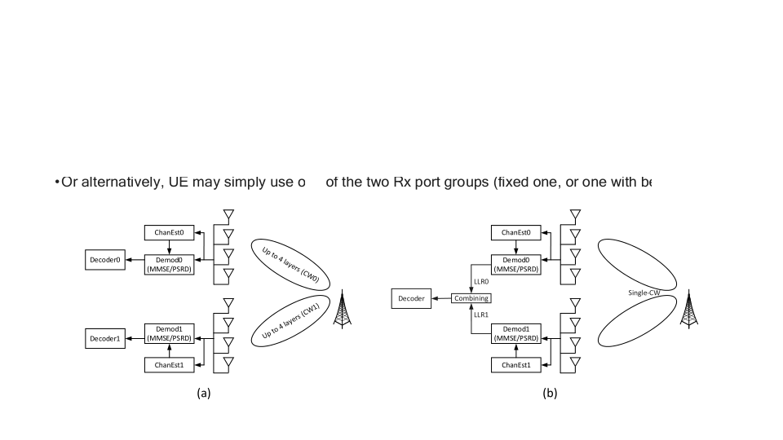

Image from Slide 6:

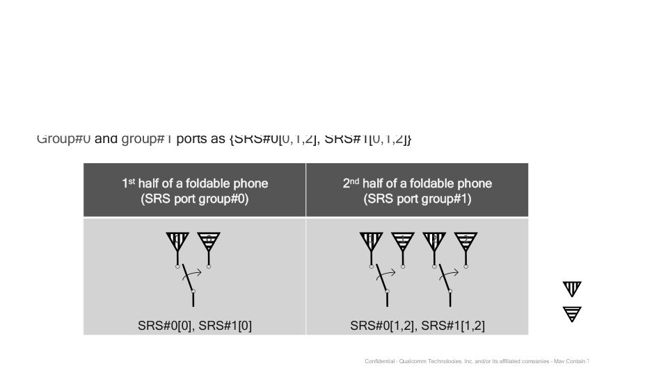

Image from Slide 7:

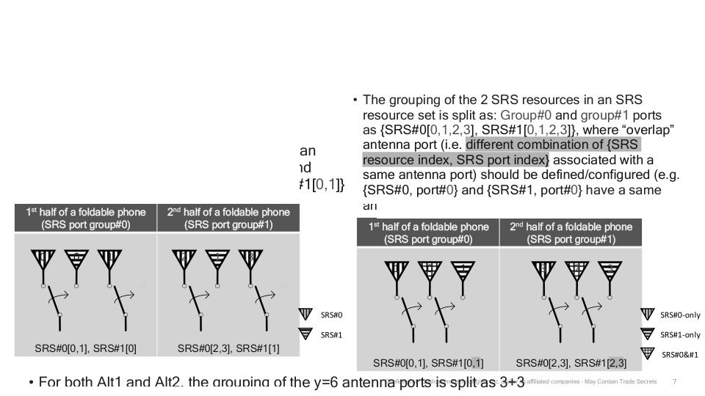

Image from Slide 8:

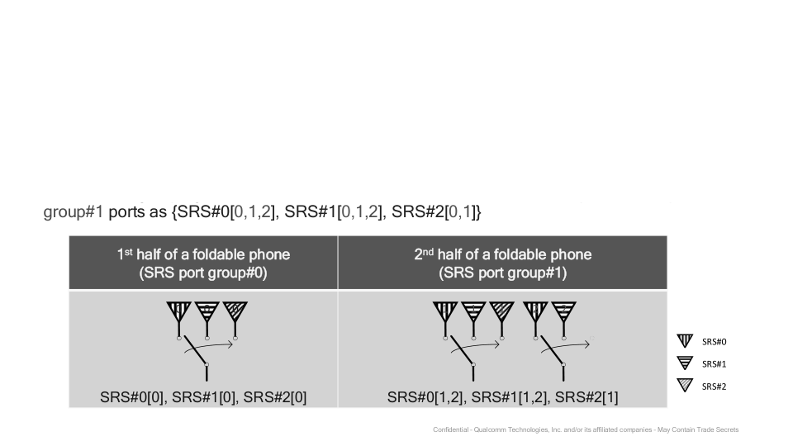

Image from Slide 9:

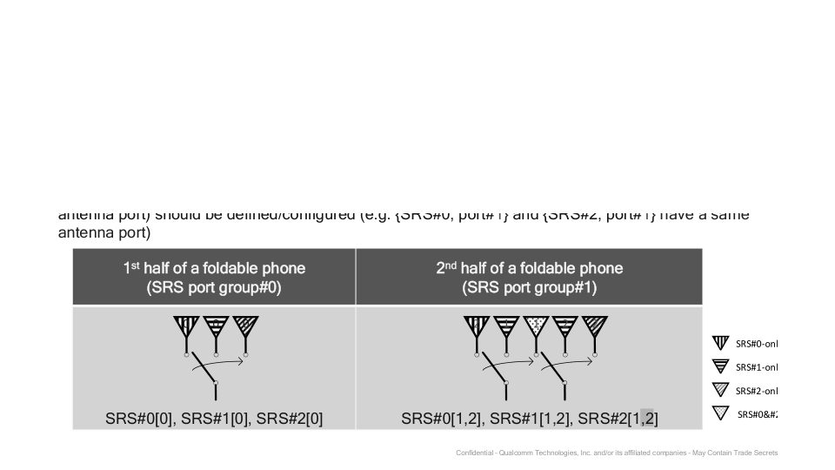

# Overall Theme

### Theme: "Innovative SRS Port Grouping for Enhanced MIMO Performance in Foldable Devices"  
  
This theme encapsulates the core ideas presented in the content, focusing on the advancements in SRS (Sounding Reference Signal) port grouping and its implications for MIMO (Multiple Input Multiple Output) technology, particularly in the context of foldable smartphones.   
  
#### Key Elements:  
1. **SRS Port Grouping**: The proposal outlines specific configurations for SRS port grouping tailored for various antenna setups (e.g., 3T6R, 4T6R, 3T8R), emphasizing the strategic division of antenna ports to optimize performance.  
  
2. **MIMO Complexity Reduction**: The discussions highlight the potential for reducing the complexity of MIMO receivers by utilizing two Rx port groups, which can lead to improved CQI (Channel Quality Indicator) calculations and overall system efficiency.  
  
3. **Foldable Phone Design Challenges**: The content addresses unique challenges posed by foldable phones, specifically regarding the RF circuitry and how SRS port grouping can be designed to accommodate the physical constraints of such devices.  
  
4. **Proposed Solutions**: Various proposals for SRS configurations are presented, showcasing innovative approaches to antenna port grouping to enhance performance while maintaining compatibility with existing standards.  
  
5. **Confidentiality and Proprietary Information**: The mention of confidential information owned by Analog Devices underscores the proprietary nature of the research and development efforts in this area.  
  
6. **Computational Efficiency**: The accompanying images illustrate advanced computational techniques, such as the DIF-FFT and radix-4 FFT, which parallel the theme of optimizing performance through systematic data processing and algorithmic efficiency.  
  
#### Keywords:  
- SRS (Sounding Reference Signal)  
- MIMO (Multiple Input Multiple Output)  
- CQI (Channel Quality Indicator)  
- Antenna Switching  
- Foldable Phones  
- RF Circuitry  
- Computational Efficiency  
- DFT (Discrete Fourier Transform)  
- FFT (Fast Fourier Transform)  
- Proprietary Technology  
  
This cohesive theme encapsulates the innovative strategies being proposed to enhance the performance of foldable devices through advanced SRS port grouping, while also addressing the technical challenges and computational methodologies involved.